Software?Software is set of Programs or instructions. use to perform some specific task by computer.

* Software is a generic term used to describe computer programs.

What is Software Testing?

* Software testing is defined as an activity to check whether the actual results match the expected results and to ensure that the software system is[Defect](https://www.guru99.com/the-unconventional-guide-to-defect-management.html)free.

How many types of Software Testing?

There are two types of Software Testing.

* Manual Testing
* Automation Testing

What is Manual Testing?

* Manual testing is the process of testing the software manually to find the defects.
* Tester should have the perspective of an end users and to ensure all the features are working as mentioned in the requirement document.
* In this process, testers execute the test cases and generate the reports manually without using any automation tools.
* Any new application must be manually tested before its testing can be automated. Manual testing requires more effort but is necessary to check  automation feasibility.

What is Automation Testing?

* Automation testing is the process of testing the software using an automation tools to find the defects.
* In this process, testers execute the test scripts and generate the test results automatically by using automation tools.
* Some of the famous automation testing tools for functional testing are QTP/UFT and Selenium.

What is SDLC?

* Software Development Life Cycle (SDLC) is a process used by the software industry to design, develop and test high quality software.
* The SDLC aims to produce a high-quality software that meets or exceeds customer expectations, reaches completion within times and cost estimates.

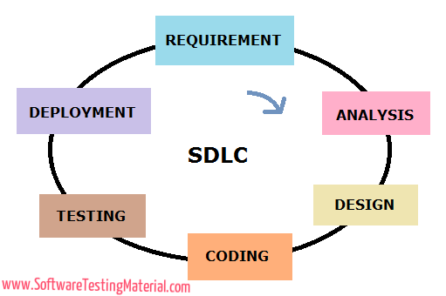

What is STLC?

* Software Testing Life Cycle (STLC) identifies what test activities to carry out and when to accomplish those test activities.
* Even though testing differs between Organizations.

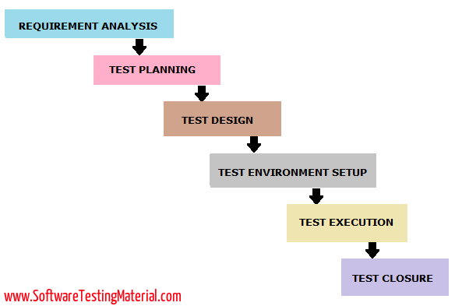

What is bug?

* A bug is the result of a coding error.
* An Error found in the development environment before the product is shipped to the customer.
* In Software testing, when the expected and actual behaviour is not matching, an incident needs to be raised. An incident may be a Bug.
* A programming error that causes a program to work poorly, produce incorrect results or crash.

What is Defect?

* Deviation between expected behaviour to actual behaviour of system is called defect.
* If testers find a mismatch in the actual and expected behaviour of an application in the testing phase then they call it as a Defect.

What is Error?

* Any Incorrect human action that produces a problem in the system is called error.
* If the developers find that there is a mismatch in the actual and expected behaviour of an application in the development phase then they call it as an Error.
* An error is a mistake, misconception, or misunderstanding on the part of a software developer.

What is Failure?

* When a defect reaches the end customer it is called a Failure.
* If customers or end users find a mismatch in the actual and expected behaviour of an application in the production phase then they call it a Failure.

How above four - Bug, Defect, Error and Failure describe as one sequence.

* Testing is the process of identifying defects, where a defect is any variance between actual and expected results. “A mistake in coding is called Error, error found by tester is called Defect, defect accepted by development team then it is called Bug, build does not meet the requirements then it Is Failure.

What is Rejected?

* If the defect is not considered as a genuine defect by the developer then it is marked as ‘Rejected’ by the developer.

What is deferred?

* If the developer feels that the defect is not of very important priority and it can get fixed in the next release or so in such a case, he can change the status of the defect as ‘Deferred’.

What is Reopen?

* If the bug persists even after the developer has fixed the bug, the tester changes the status to "reopened". Once again, the bug goes through the life cycle.

Why does software have defects?

* Incorrect requirements
* Wrong design
* Poor coding
* Complex business logic
* Complex technology
* Work pressure
* Frequently changing requirements.

“A clever person solves a problem. A wise person avoids it.” *Albert Einstein*

What is Retest?

* Retesting is done to make sure that the tests cases which failed in last execution are passing after the defects against those failures are fixed.

What is a Regression Test?

* Regression Testing is defined as a type of software testing to confirm that a recent program or code change has not adversely affected existing features.
* Regression Testing is nothing but a full or partial selection of already executed test cases which are re-executed to ensure existing functionalities work fine.

What is Smoke Testing?

* Software Testing done to ensure that whether the build can be accepted for through software testing or not. Basically, it is done to check the stability of the build received for software testing.

What is a Sanity Test?

* After receiving a build with minor changes in the code or functionality, a subset of regression test cases are executed to check whether it rectified the software bugs or issues and no other software bug is introduced by the changes.

What is a Software Build?

* If you are developing a simple computer program which consists of only one source code file, you merely need to compile and link this one file, to produce an executable file. This process is very simple.
* Usually, this is not the case. A typical Software Project consists of hundreds or even thousands of source code files. Creating an executable program from these source files is a complicated and time-consuming task.
* You need to use "build" software to create an executable program and the process is called " Software Build"

What are your team size?

Ans. In my team we are 7 members,

1- PO-1

2- Team Lead-1

3- Architect-1

4- Frontend Developer-1

5- Developer-2

6- QA-1

What is difference between Smoke testing and Sanity Testing?

* The difference between smoke and sanity testing is described below:
* Sanity testing is performed when a new build is released after fixing bugs whereas smoke testing is performed to check the major functionalities of the application.
* Sanity is performed by the tester or the developer but smoke testing can be performed by the tester or developer.
* Smoke testing is performed earlier whereas sanity is performed after the smoke testing.
* Sanity testing is narrow and deep approach of testing and smoke testing is focused testing based on major functionalities.

What is the difference between Retesting and Regression testing?

* The difference between Retesting and Regression testing are below:
* Retesting is done to verify defects fixes where as regression is perform to check if the defect fix have not impacted other functionality that was working fine before doing changes in the code.
* always specific to any defect fix. Also regression can be executed for some modules or all modules. Retesting is planned testing based on the defect fixes listed where as regression is not be a
* Retesting concern with executing those test cases that are failed earlier whereas regression concerns with executing test cases that was passed in earlier builds.
* Retesting has higher priority over regression, but in some case retesting and regression testing are carried out in parallel.

What is the difference between build and release?

* BUILD: is a number given to installable software that is given to the testing team for testing by the development team. Build numbers assigned are incremental and sequential.
* RELEASE: is a number given to installable software that is handed over to the customer by the developer or tester.
* The information of build, release and version are displayed in software help page. Using this build and release customer can let the customer team know which release version build that are using.
* e.g. "9.4.123.2" (Release Number, Version Number, Build Number, Patch Number)

What the purpose of testing?

* Software Testing: is the process of assuring that product which is developed by the manufactured by
* developer is meeting the user requirement. The motive to perform testing is to find the bugs and make sure that they get fixed. The purposes of testing are following:
* Quality assurance, Verification and Validation,
* To find the bugs before the product is released to customer.
* To improve the quality of the product
* The Purpose of Testing is to evaluate that the product is according to requirements